Curriculum Vitae _ Salah Nori Farhan

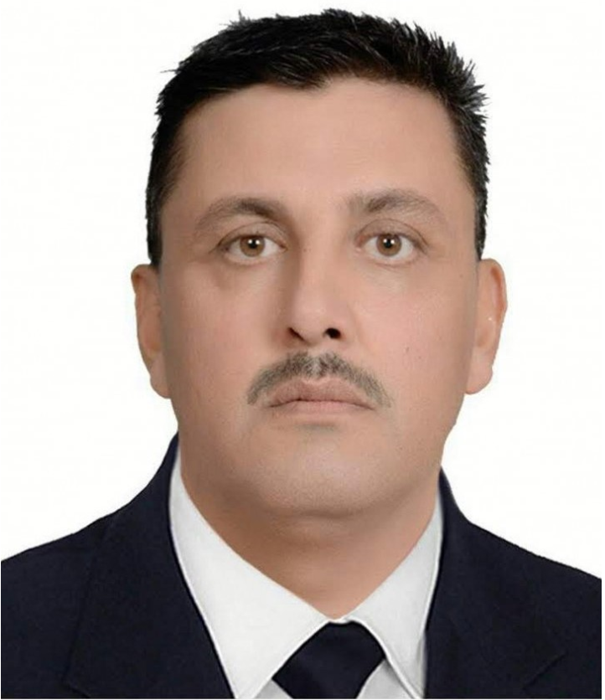
Personal Information.
Academic degree: Lecturer
Birth Date & Place: January, 1, 1972 – Iraq
Nationality: Iraqi
Marital Status: Marrie d –
Email: drsalahchem@uodiyala.edu.iq
Website: www.uodiyala.edu.iq

Scopus:- Author ID: 57103078000
ResearcherID: A-2599-2019
ORCID orcid.org/0000-0002-3482-6754
EDAS identifier | 1459052
https://www.mendeley.com/profiles/salah-n-farhan/
Driving License: Iraqi International Driving License.
Postal address: College of Engineering, Daiyla University, Baquba City, Daiyla Governorate, ZIP 32001, Iraq.
Professional Strength and Skills.
- Very effective in biosorption process , especially the removal of heavy metal ions from aqueous solution and industrial effluent .
- Wide theoretical knowledge in most subject of chemical engineering such as mass transfer, heat transfer, fluid flow, thermodynamics, rector design, mathematics, engineering analysis.
Educational Qualifications.
- Academic visitor 2011 School of pharmacy and chemistry Reading University (UK).
- Ph.D. Chemical Engineering 2004-2008 Chemical Engineering Dept. University of Technology -Iraq. (English Curriculum) Rating (Excellent).
Thesis title: Removal of Heavy Metals from aqueous solution by biosorption
- Ms. C. Chemical Engineering 1998-2001 Chemical Engineering Dept. University of Technology -Iraq. (English Curriculum) Rating (very good).
Thesis title: Study optimization condition of batch sterilization using genetic algorithm.

- B.Sc. Chemical Engineering 1989-1993 Chemical Engineering Dept. University of Technology -Iraq. (English Curriculum) Rating (medium).
Graduation Project: Methane production using biomass fermentation.

Memberships and Academic positions.
- Instructor - College of Engineering – Diyala University since 2012 till now.
● Assistants dean of administration affairs-College of Science, Diyala Univ. 2009-2012.
- Member in Iraqi Engineer Union 1994 till now
- Coordinator - College of Science – Diyala University since 2002 - 2004.
- Member of Iraqi Engineers Union (IEU) since 1994 till now.
- Member in Iraqi Teacher Union 2009 till now.

Training and Courses .
● Lecturer in work shop” how to deals with chemicals” University of Diyala 2014.
- Training course for one month in Chemical Safety and Security Officer Training-University of Al Nahrain with Arab science Foundation and Sandia Lab. - 2012.
- HPLC training course, Amman , Jordan 2012
- Training course for one month in Reading University – United Kingdom - 2011.
- Lecturer in Chemical Safety training, University of Diyala 2011
- Computer Programming Course for one month in College of Education–Computer Department – Baghdad University – Iraq - 2002.
- Methods of Teaching Course for one month in College of Education– Diyala University – Iraq - 2002.
- English Language Certificate - College of Languages – Baghdad University – Iraq - 1997.

Languages.
- English: Written and spoken (Very good)
- Arabic: Mother tongue.

Employment History (Academic & Technical).
Diyala University – College of Engineering (2012 – till now)
Location: Diyala – Iraq
Position: Instructorr, editorial manager of Diyala Journal of Engineering Sciences.
Academic degree: Lecturer.
Description: Teaching Mathematics (Engineering Calculus I) for the first stage and fluid flow for second stage and reactor design for third stage and unit operation for fourth stage.
Diyala University – College of Science (2002 – 2012)
Location: Diyala – Iraq
Position: lecturer, Decider of Chemistry Department, College of Science, Diyala University 2001-2002
Planning manager of College of Science, Diyala University 2002-2004
Assistant dean of administration affairs, instructor, College of sciences 2009-2012
Description: Teaching Mathematics (Engineering Calculus I&II) for the first and second stage and Biochemistry for third and fourth stage.
Ministry of Industry 2001-2002
Consultant in general company for leather industry.
Consultant in general company for oil industry.
Al-Diyaa Company for leather and pigment production (1999-2001)

Location: Diyala – Iraq
Position: Production Engineer, Technical manager of Al-Diah Company for polymer products.
Description: Working in the company lab. To prepare the batch product then scaling up these lab. Results to the main process.
Secondary education (1996-1999)
lecturer teaching mathematics and chemistry
Published Research Papers.

No | Title of research | Journal name | Publisher | ISSN
1 | (study optimization condition of batch sterilization using GA); | Engineering and Technology Journal | University of Technology-Iraq | 2412-0758
2 | Biosorption of heavy metals from aqueous solutions by Saccharomyces Cerevisiae | International Journal of Industrial Chemistry | Springer Nature | 2228-5547
3 | Biosorption of copper and lead ions using Wheat Husk | Diyala Journal of Engineering Science | College of Engineering –University of Diyala | 2616-6909
4 | Copper and Lead Ions Removal From Aqueous Solution Using MgO,Nanostractured MgO | Applied Chemical Engineering | EnPress Journals | 2578-2010
5 | Biosorption of Hg and Ni ions on Bakers Yeast | Diyala Journal for Pure Science | College of Science - University of Diyala | 2518-9255
6 | Corrosion inhibition of steel in phosphoric acid | Corrosion Reviews | De Gruyter | 2191-0316
7 | Corrosion of Crude Oil Distillation Column: Kinetics and Mathematical Views | Journal of Bio- and Tribo-Corrosion | Springer Nature | 2198-4239
8 | Ethanol Production from Modified Wheat Straw using Saccharomyces cerevisiae | International Journal on Emerging Technologies | Research Trend | 2249-3255
9 | Pre-evaporation of Ethanol as an Effective Method to Improve Single Cell Protein (SCP) Production from Date Palm Residue by Saccharomyces Cerevisiae | Materials Science and Engineering | IOP Publishing | 1757-899X
10 | Mathematical and Artificial Neural Network Models for Corrosion of High Temperature – High Pressure Boiler Pipes in Presence of Oxygen Scavengers | IEEE | 2018 1st International Scientific Conference of Engineering Sciences - 3rd Scientific Conference of Engineering Science (ISCES) | 17719303
11 | Monitoring Water Quality Parameters of Khirisan River in Iraq | Journal of Advanced Research in Fluid Mechanics and Thermal Sciences | Penerbit Akademia Baru | 2289-7879
12 | Rheological Behavior of Isothermal Cured Epoxy/1,4-Diaminobenzene Systems | Diyala Journal of Engineering Science | College of Engineering –University of Diyala | 2616-6909
13 | Statistical Investigation as a Tool for Corrosion Data Explanations and Forecasting of Reliable Operating Regions | Chemistry Africa | Springer, Co-Publisher Tunisian Chemical Society | 2522-5766
14 | The Boiler Pipes Failure in Power Plants (South of Baghdad Station | Journal of Engineering and Applied Sciences | Medwell | 1818-7803
15 | Biosorption of Copper and Lead Ions Using Chara Algae | Pakistan Journal of Engineering and Applied Sciences | University of Engineering and Technology, Lahore | 2415-0584

Conferences.

First conference, College of Science, Diyala Univ. ( 2009).
Second conference, College of Science, Diyala Univ. ( 2013).
Second conference, College of engineering, Diyala Univ. ( 2015).
Published Books .

Reviewer and referee
(1) Diyala Journal of Engineering Sciences
(2) Engineering and International Conference for College of Engineering
(3) Biomass Conversion and Biorefinery
(4) International Scientific Conference of Engineering Sciences
(5) Iraqi Journal of Nanotechnology
(6) World Journal of Engineering
(7) Journal of Materials and Environmental Science
(8) Chemosphere
(9) Nova Biotechnologica et Chimica
(10) Basrah Journal for Engineering Science

Awards and Prizes .

